**Business Economics**

For a layman, the economic world is a complex place. Usually, economic theories are simple and hypothetical in nature. Hence, most managers find a difference between the propositions of these theories and the real economic world. This is where Business Economics steps in**.** It enables the application of economic logic and analytical tools and attempts to bridge the gap between theory and practice.

**Business economics is a field in applied economics which uses economic theory and quantitative methods to analyze business enterprises and the factors contributing to the diversity of organizational structures and the relationships of firms with labour, capital and product markets.**

Before we start to study the nature of business economics, it is important to understand that economics is broadly divided into two major parts:

* Micro Economics
* Macro Economics

### Micro Economics

This is the study of the way individual units make decisions regarding the efficient allocation of their scarce resources. Also, these individual units are consumers or firms. In microeconomics, the focus is on a small number of units rather than all units combined. Further, it does not give us a picture of the happenings in the wider economic environment. The study includes:

* Product pricing;
* Consumer behavior;
* Factor pricing;
* The economic conditions of a section of people;
* The behavior of firms; and
* Location of the industry.

### Macro Economics

This is the study of the behavior of large economic aggregates like overall output levels, total consumption, etc. The study also includes the shift of these aggregates over time. Therefore, macroeconomics analyzes the overall economic conditions which are an overall effect of millions of decisions made by different firms and consumers.

* National Income and National Output;
* The general price level and interest rates;
* A balance of trade and balance of payments;
* The external value of currency;
* The overall level of savings and investment; and
* Level of employment and rate of economic growth.

## Nature of Business Economics

### 1. Business Economics is a Science

What is Science? It is simply a systematic body of knowledge which can establish a relationship between cause and effect. Further, Mathematics, Statistics, and Econometrics are decision sciences.

Business Economics integrates these decision sciences with Economic Theory to arrive at strategies to help businesses achieve their goals. Hence, it follows scientific methods and also tests the validity of the results. This is one aspect of the nature of business economics.

### 2.It is based on Micro Economics

We understand the basic difference between micro and macroeconomics. A business manager is certainly more concerned about achieving the objectives of his own organization. After all, this helps him in ensuring profits and long-term survival of the firm. Business Economics is more concerned with the decision-making situations of individual establishments. Therefore, it depends on the techniques of Microeconomics.

### 3.It incorporates elements of Macro Analysis

Even though all businesses focus on their profitability and survival, a firm cannot operate in a vacuum. The external environment of the economy like income and employment levels in the economy, tax policies, etc., affects the firm. All these external factors are components of Macro economy. Therefore, a business manager has to take all such factors into consideration which may influence his business environment.

### 4.It is an Art

Business Economics is an art as it requires the practical application of rules and principle to achieve set objectives.

### 5.Use of Theory of Markets and Private Enterprises

Business Economics primarily uses the theory of markets and private enterprises. It uses the theory of the firm and resource allocation in a private enterprise economy.

### 6.Pragmatic in Approach

Microeconomics is purely theoretical and analyzes economic occurrences under unrealistic assumptions. On the other hand, Business Economics is pragmatic in its approach. It tries to solve the problems which the firms face in the real world.

### 7.Interdisciplinary

Business Economics incorporates tools from many other disciplines like mathematics, statistics, accounting, marketing, etc. Therefore, is in interdisciplinary in nature.

### 8.Normative Science

Broadly speaking, Economic Theory has evolved along two lines – Positive and Normative.

A positive or pure science analyzes the cause and effect relationship between variables in a scientific manner. However, it does not involve any value judgment. In simpler words, it describes the economic behavior of individuals or society without focusing on the desirability of such behavior.

On the other hand, a normative science involves value judgments. It suggests a course of action under the given circumstances.

Usually, Business Economics is normative in nature. It offers suggestions for the application of economic principles while forming policies, making decisions, and planning for the future. However, firms must understand their environment thoroughly to establish decision rules. This requires the study of positive economic theory.

Therefore, we can say that Business Economics combines the essentials of both the theories while keeping more emphasis on the normative economic theory.

**Subject Matter/Scope of Business Economics**

As regards the scope of [business economics](http://www.texilaedu.org/product-category/business-management/), no uniformity of views exists among various authors. However, the following aspects are said to generally fall under business economics.

* 1. Demand Analysis and Demand Forecasting
  2. Production Analysis
  3. Cost Analysis and Pricing in various Markets
  4. Profit Management
  5. Capital Management

**Demand Analysis and Demand Forecasting**

The objective of Demand Analysis is to know consumers behavior. It answers to the questions, why do consumers buy a commodity? When do they stop consuming a commodity? How do the consumers behave when a change occurs in price of a commodity, their income, taste and preferences etc., thus, knowledge of demand theory and demand analysis is essential in making decisions in the choice of commodities for production.

Demand forecasting enables the management to strengthen market position and also enlarge profits. Therefore the demand determination, demand distinction and demand forecasting occupies a strategic role in the subject matter of Business economics.

**Production Analysis**

Production theory, also called as theory of firm explains the way the output is increased when units of one factor input or all factors are increased. The theory explains how optimum output is obtained with minimum cost. In brief, it helps in determining the size of the firm, size of the total output and the factor proportion.

**Cost Analysis & Markets**

It covers various costs, so that the firm can as well think interms of reducing the same. The relationship between cost and output makes the managers of the firm to produce in an ideal way and make him to serve in midst of other competitive producers, while ensuring considerable profit.

It even explains the way the prices are determined under different market situations (monopoly, Perfect Competition etc). Hence the cost concepts, cost-output relationships in the short-run and long-run, price determination and pricing methods etc also dominating the subject contention of Business Economics.

**Profit Management**

The survival as well as the success of every organization depends upon its ability to earn and also maximize profit. However, a satisfactory level of profit is not always guaranteed as the firm has to carry out its activities under conditions of uncertainty in regard to (a) demand for the product (b) input prices in the factors market (c) nature and degree of competition in the product market (d) price behavior under changing conditions in the product market etc. therefore, an element of risk is always exists even if most efficient techniques are used for predicting future, and even if business activities are meticulously planned.

The firms are therefore to safeguard their interest and avert as far as possible the possibilities of risk or minimize the risk. Profit theory guides in the measurement and management of profit, in making allowances for risk premium, in calculating the pure return of capital and pure profit and also in future profit planning.

**Capital Management**

Capital, like all other inputs, is also one of the scarce and an expensive factor. Capital is the foundation of a business. Its efficient allocation and management is one of the most important tasks of the managers. The major issues related to capital are (a) choice of capital (b) assessing the efficiency of capital (c) most efficient allocation of capital.

Knowledge of capital theory can contribute a great deal in investment decision, choice of projects, maintaining capital intact, capital budgeting etc., and has its own vital bearing in the subject code of Business Economics.

In brief the subject matter of Business Economics is concerned with the application of economic principles and concepts, to keep a balance over the typical types of five uncertainties viz., Demand Uncertainty, Cost Uncertainty, Price Uncertainty(in various markets), Profit Uncertainty and Capital Uncertainty.

## Business Cycle

A business cycle is a cycle of fluctuations in the [Gross Domestic Product](https://corporatefinanceinstitute.com/resources/knowledge/economics/gdp-formula/) (GDP) around its long-term natural growth rate. It explains the expansion and contraction in [economic activity](https://corporatefinanceinstitute.com/resources/knowledge/economics/definition-market-economy/)that an economy experiences over time.

A business cycle is completed when it goes through a single boom and a single contraction in sequence. The time period to complete this sequence is called the length of the business cycle.

A boom is characterized by a period of rapid economic growth whereas a period of relatively stagnated economic growth is a recession.

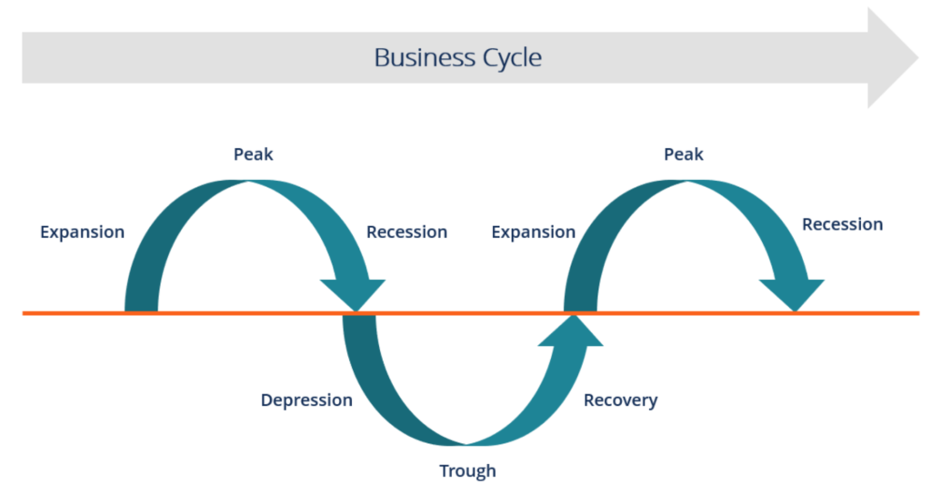

### Stages/phases of the Business Cycle

In the diagram above, the straight line in the middle is the steady growth line. The business cycle moves about the line.  Below is a more detailed description of each stage in the business cycle:

#### Expansion

The first stage in the business cycle is expansion. In this stage, there is an increase in positive economic indicators such as employment, income, output, wages, profits, demand, and supply of goods and services. Debtors are generally paying their debts on time, the velocity of the money supply is high, and investment is high. This process continues until economic conditions become favorable for expansion.

#### Peak

The economy then reaches a saturation point, or peak, which is the second stage of the business cycle. The maximum limit of growth is attained. The economic indicators do not grow further and are at their highest. Prices are at their peak. This stage marks the reversal in the trend of economic growth. Consumers tend to restructure their budget at this point.

#### Recession

The recession is the stage that follows the peak phase. The demand for goods and services starts declining rapidly and steadily in this phase. Producers do not notice the decrease in demand instantly and go on producing, which creates a situation of excess supply in the market. Prices tend to fall. All positive economic indicators such as income, output, wages, etc. consequently start to fall.

#### Depression

There is a commensurate rise in unemployment. The growth in the economy continues to decline, and as this falls below the steady growth line, the stage is called depression.

#### Trough

In depression stage, the economy’s growth rate becomes negative. There is further decline until the prices of factors, as well as the demand and supply of goods and services, reach their lowest. The economy eventually reaches the trough. This is the lowest it can go. It is the negative saturation point for an economy. There is extensive depletion of national income and expenditure.

#### Recovery

After this stage, the economy comes to the stage of recovery. In this phase, there is a turnaround from the trough and the economy starts recovering from the negative growth rate.

Demand starts to pick up due to the lowest prices and consequently, supply starts reacting, too. The economy develops a positive attitude towards investment and employment and hence, production starts increasing.

Employment also begins to rise and due to the accumulated cash balances with the bankers, lending also shows positive signals. In this phase, depreciated capital is replaced by producers, leading to new investment in the production process. Recovery continues until the economy returns to steady growth levels.

This completes one full business cycle of boom and contraction. The extreme points are the peak and the trough.

**National Income**

National Income is the total flow of wealth produced, distributed, consumed and saved with in the country during a given period of time.

It can be even viewed as the money value of all the goods and services produced in a country during a financial year. In other words, the final outcome of all the economic activities of the nation during a period of one year, valued in terms of money is called as a **National income**.

**Methods for Measuring National Income**

The national income of a country can be measured by three alternative methods: (i) Product Method (ii) Income Method, and (iii) Expenditure Method.

**1. Product Method:**

In this method, national income is measured as a flow of goods and services. We calculate money value of all final goods and services produced in an economy during a year. Final goods here refer to those goods which are directly consumed and not used in further production process.

Goods which are further used in production process are called intermediate goods. In the value of final goods, value of intermediate goods is already included therefore we do not count value of intermediate goods in national income otherwise there will be double counting of value of goods.

To avoid the problem of double counting we can use the value-addition method in which not the whole value of a commodity but value-addition (i.e. value of final good value of intermediate good) at each stage of production is calculated and these are summed up to arrive at GDP.

The money value is calculated at market prices so sum-total is the GDP at market prices

**2. Income Method:**

Under this method, national income is measured as a flow of factor incomes. There are generally four factors of production labour, capital, land and entrepreneurship. Labour gets wages and salaries, capital gets interest, land gets rent and entrepreneurship gets profit as their remuneration.

Besides, there are some self-employed persons who employ their own labour and capital such as doctors, advocates, CAs, etc. Their income is called mixed income. The sum-total of all these factor incomes is called NDP at factor costs.

**3. Expenditure Method:**

In this method, national income is measured as a flow of expenditure. GDP is sum-total of private consumption expenditure. Government consumption expenditure, gross capital formation (Government and private) and net exports (Export-Import).

**Importance/Significance of National Income**

#### ****1. Economic Policy:****

National income figures are an important tool of macroeconomic analysis and policy.

National income estimates are the most comprehensive measures of aggregate economic activity in an economy.

It is through such estimates that we know the aggregate yield of the economy and can lay down future economic policy for development.

#### 2. Economic Planning:

National income statistics are the most important tools for long-term and short-term economic planning. A country cannot possibly frame a plan without having a prior knowledge of the trends in national income. The Planning Commission in India also kept in view the national income estimates before formulating the five-year plans.

#### 3. Economy’s Structure:

National income statistics enable us to have clear idea about the structure of the economy. It enables us to know the relative importance of the various sectors of the economy and their contribution towards national income. From these studies we learn how income is produced, how it is distributed, how much is spent, saved or taxed.

#### 4. Inflationary and Deflationary Gaps:

National income and national product figures enable us to have an idea of the inflationary and deflationary gaps. For accurate and timely anti- inflationary and deflationary policies, we need regular estimates of national income.

#### 5. Budgetary Policies:

Modern governments try to prepare their budgets within the framework of national income data and try to formulate anti-cyclical policies according to the facts revealed by the national income estimates. Even the taxation and borrowing policies are so framed as to avoid fluctuations in national income.

#### 6. National Expenditure:

National income studies show how national expenditure is divided between consumption expenditure and investment expenditure. It enables us to provide for reasonable depreciation to maintain the capital stock of a community. Too liberal allowance of depreciation may prove harmful as it may unnecessarily lead to a reduction in consumption.

#### 7. Distribution of Grants-in-aid:

National income estimates help a fair distribution of grants-in-aid by the Central government to the state governments and other constituent units.

#### 8. Standard of Living Comparison:

National income studies help us to compare the standards of living of people in different countries and of people living in the same country at different times.

#### 9. International Sphere:

National income studies are important even in the international sphere as these estimates not only help us to fix the burden of international payments equitably amongst different nations but also enable us to determine the subscriptions and quotas of different countries to international organizations like the UNO, IMF, IBRD. etc.

#### 10. Defence and Development:

National income estimates help us to divide the national product between defence and development purposes. From such figures we can easily know how much can be spared for war by the civilian population.

#### 11. Public Sector:

National income figures enable us to know the relative roles of public and private sectors in the economy. If most of the activities are performed by the state, we can easily conclude that public sector is playing a dominant role.

**Supply**

Supply refers to the amount of a good or service that the producers/providers are willing and able to offer to the market at various prices during a period of time.

## Determinants of Supply

While price is an important aspect for determining the willingness and desire to part with goods/services, many other factors determine the supply of a product or service as discussed below:

### 1.Price of the Good/ Service

The most obvious one of the determinants of supply is the price of the product/service. With all other parameters being equal, the supply of a product increases if its relative price is higher. The reason is simple. A firm provides goods or services to earn profits and if the prices rise, the profit rises too.

### 2.Price of Related Goods

Let’s say that the price of wheat rises. Hence, it becomes more profitable for firms to supply wheat as compared to corn or soya bean. Hence, the supply of wheat will rise, whereas the supply of corn and soya bean will experience a fall.

Hence, we can say that if the price of related goods rises, then the firm increases the supply of the goods having a higher price. This leads to a drop in supply of the goods having a lower price.

### 3.Price of the Factors of Production

Production of a good involves many costs. If there is a rise in the price of a particular factor of production, then the cost of making goods that use a great deal of that factors experiences a huge increase. The cost of production of goods that use relatively smaller amounts of the said factor increases marginally.

For example, a rise in the cost of land will have a large effect on the cost of producing wheat and a small effect on the cost of producing automobiles.

Therefore, the change in the price of one factor of production causes changes in the relative profitability of different lines of production. This causes producers to shift from one line to another, leading to a change in the supply of goods.

### 4.State of Technology

Technological innovations and inventions tend to make it possible to produce better quality and/or quantity of goods using the same resources. Therefore, the state of technology can increase or decrease the supply of certain goods.

### 5.Government Policy

Commodity taxes like excise duty, import duties, GST, etc. have a huge impact on the cost of production. These taxes can raise the overall costs. Hence, the supply of goods that are impacted by these taxes increases only when the price increases. On the other hand, subsidies reduce the cost of production and usually lead to an increase in supply.

### Other Factors

There are many other factors affecting the supply of goods or services like number of sellers, the quality of the product, the governments industrial and foreign policies, the goals of the firm, infrastructural facilities, market structure, natural factors etc.

**Law of Supply**

The law of supply is the [microeconomic](https://www.investopedia.com/university/microeconomics/) law that states that, all other factors being equal, as the price of a good or service increases, the quantity of goods or services that suppliers offer will increase, and vice versa.

The[law of supply](https://www.investopedia.com/terms/l/lawofsupply.asp) says that as the price of an item goes up, suppliers will attempt to maximize their profits by increasing the quantity offered for sale.

The chart below depicts the law of supply using a supply curve, which is always upward sloping. A, B and C are points on the supply curve. Each point on the curve reflects a direct correlation between quantities supplied (Q) and price (P). So, at point A, the quantity supplied will be Q1 and the price will be P1, and so on.

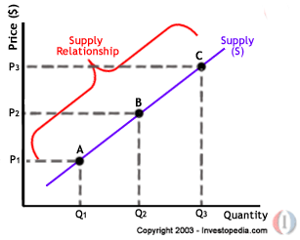

**Supply Function**

Is a simple mathematical expression which will be explaining us the relationship that exists between supply and its determinants.

Qx = f(px, pr, pf, T, t, S, N, O etc)

Qx = Total quantity supplied of the commodity ‘X’

Px = Price of the good ‘X’

Pr = Price of related goods

Pf = price of factor inputs

T=improvements in production technology

t = tax policy

S = subsidy policy

N = number of sellers and size of the market

O = other factors like quality, market structures etc